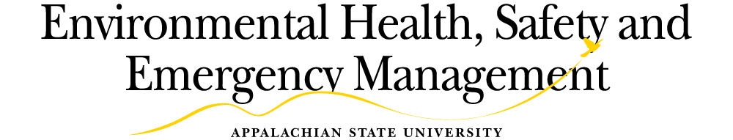

Multi-Passenger Vehicle Driver and Supervisor Acknowledgement Form Driver Acknowledgement
- As the driver, I understand that I am responsible to follow the guidelines presented in the Multi-Passenger Vehicle Driver Awareness Guide and pertinent information presented in the video.

- It is my responsibility to inspect the vehicle before driving and report any safety or maintenance concerns to my supervisor.

- It is my responsibility to check the air pressure and tread depth on the tires before driving each day.

- It is my responsibility to make sure that I and all passengers are wearing seat belts at all times while in the vehicle.

- I understand I am not allowed to operate the vehicle if I have consumed any alcohol within the previous 12 hours.

- I understand I am not allowed to use a cell phone or any electronic device in my ears or on my head while driving.

- I understand I am not allowed to operate the vehicle while on any type of drugs that could affect my driving ability.

- I understand I must report all accidents to Motor Pool at 828-262-3190x160, EHS&EM at 828-262-4008, and to my supervisor immediately after calling 911.

- I understand I must report any violations I commit in any vehicle (private or state owned) within 48 hours and I am responsible for any fines related to such violations.

Driver's Signature Printed Name Date

It is recommended that the supervisor give the driver behind the wheel experience in the vehicle that the driver will be asked to drive.

Supervisor Acknowledgement

I understand it is my responsibility to ensure that any safety or maintenance issues brought to my attention by the driver are addressed properly and that the driver has access to a tire air pressure and depth gauge prior to each trip to take on the trip.

Supervisor Signature Printed Name Date

